-  21.05.2019

**Homework 1_ Test cases writing techniques**

Suppose you have very important tool at office, accepts valid Username and Password field to work on that tool, and accepts minimum 8 characters and maximum 12 characters. Valid range 8-12, Invalid range 7 or less than 7 and Invalid range 13 or more than 13.

**Write Test Cases for Valid partition value, Invalid partition value and exact boundary value.**

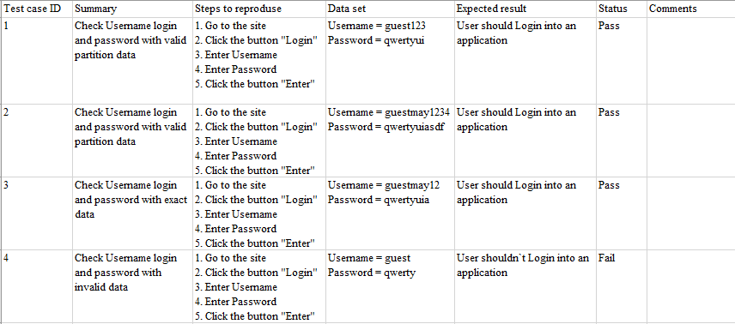

**Homework 2_ Test cases writing techniques**

Test cases for the application whose input box accepts numbers between 1-1000. Valid range 1-1000, Invalid range 0 and Invalid range 1001 or more.

**Write Test Cases for Valid partition value, Invalid partition value and exact boundary value.**

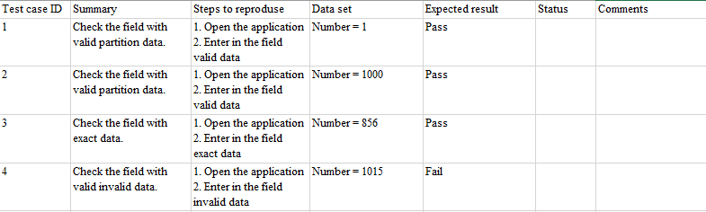

**Homework 3_ Test cases writing techniques**

**How many statements, how many decision coverage test cases do you see?**

Statements: two statements

Decision: one decision